Types of Complements
# Source: AI Source: Provided by: [Data Path: Persons Table -> ID Column: 1, Name_En Column: Motasem Essam] -> From: [ChatGPT] on [8/4/2025]
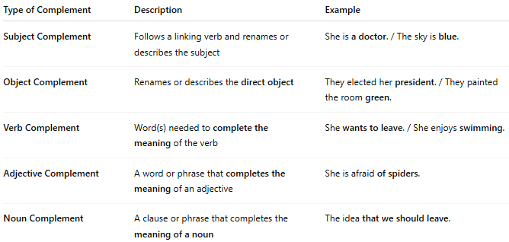

Type of Complement | Description | Example
Subject Complement | Follows a linking verb and renames or describes the subject | She is a doctor. / The sky is blue.
Object Complement | Renames or describes the direct object | They elected her president. / They painted the room green.
Verb Complement | Word(s) needed to complete the meaning of the verb | She wants to leave. / She enjoys swimming.
Adjective Complement | A word or phrase that completes the meaning of an adjective | She is afraid of spiders.
Noun Complement | A clause or phrase that completes the meaning of a noun | The idea that we should leave.

